* **Output:** In pom.xml file → junit dependency added

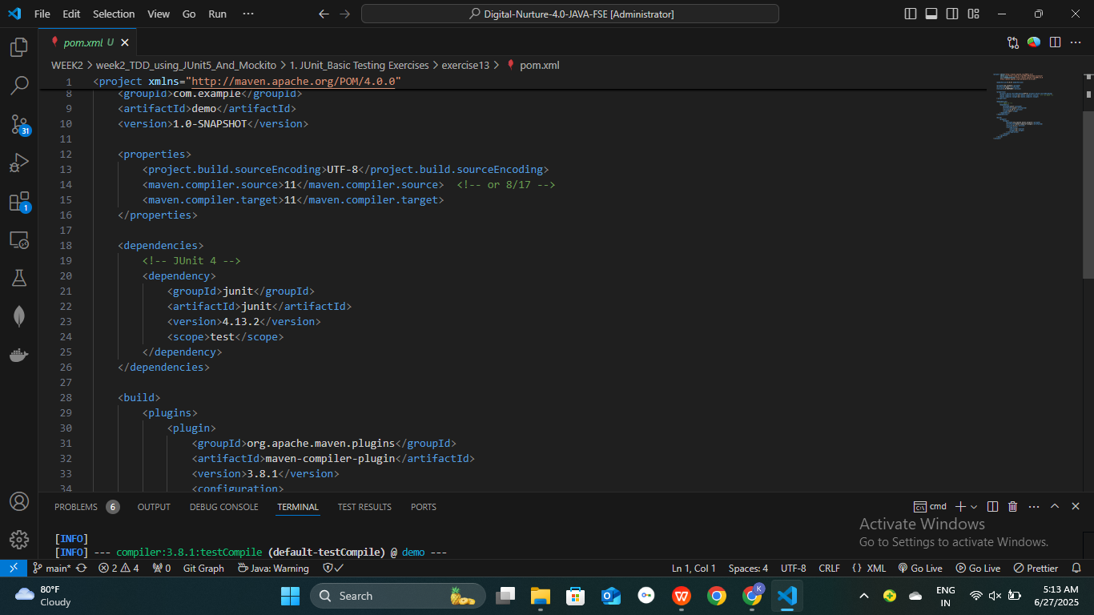

* **Build Result:** After doing maven clean install the output is given below…

